**Process Book**

COS30045: Data Visualisation

**Ukrainian Refugees During Russian Invasion**

Huy Vu Tran - 104177995

Thai Anh Bui – 104221643

04/01/2024

<https://mercury.swin.edu.au/cos30045/s104177995/Project/index.html>

**Table of Contents**

1. Introduction 3

**1.1. Background and Motivation 3**

**1.2. Project Objectives 4**

**1.3. Project Schedule 5**

2. Data 6

**2.1. Data Source 6**

**2.2. Data Processing 7**

3. Requirements 8

**3.1. Must have features 8**

**• A choropleth map of the EU with selected countries 8**

**• A line graph for Ukrainian refugees by nation 8**

**3.2 Optional features 9**

**• Line chart transition effect 9**

**• Choropleth map transition and animation effect 9**

4. Visualisation design 9

**4.1 Design Ideas 9**

**• Choropleth map 10**

**• Line chart 11**

**4.2 Initial progress 12**

**• Choropleth map 12**

**• Line chart 14**

**4.3 Intention of Choosing Visualisation Types 15**

**• Choropleth map 15**

**● Line chart 16**

5. Conclusion 17

6. References 18

# 1. Introduction

## 1.1. Background and Motivation

Due to the inception of war between Russia and Ukraine in 2014, this staggering conflict has caused widespread instability and human misery. The war, which began because of geopolitical tensions and Russia's annexation of Crimea, has grown into a long and costly struggle. It has detrimentally influenced the economic growth of several nations around the world. The conflict, marked by armed confrontations, political turmoil, and humanitarian crises, has pushed millions of Ukrainians to evacuate their homes in search of safety and shelter. This massive relocation has been a focal point of world attention, emphasizing the critical need for humanitarian aid and political settlement. Understanding the intricacies and consequences of this war is critical for tackling the serious issue of migration from Ukraine and devising effective methods to serve displaced populations while also promoting regional peace and stability. Thus, this report aims to investigate the issue of migration of Ukrainians influenced by the antipathy with Russia, which could assist in providing valuable insights and develop future strategies illuminating the multifaceted factors driving migration patterns.

Our team has undertaken the task of developing visual representations concerning the migration dynamics observed among Ukrainians. This visualisation, by providing a thorough and analytical picture of migration trends, can help to promote the awareness of individuals and create a greater understanding of the unique experiences and contributions of Ukrainian migrants to Western cultures.

## 1.2. Project Objectives

This data visualisation enables users to have comprehensive insights and perspectives about the issue of Ukrainians migrating to European countries. Some questions related to this problem could be:

* Where did refugees fleeing Ukraine mostly come?
* What are the overall trends in migration of Ukrainians to European countries from 2022 to 2023?
* Compare migrants after the conflict between Russia and Ukraine, hence we could figure out the migration patterns among Ukrainians.

After delving into this visualisation and investigating a relevant data source, some advantages that users can be offered include:

- Creating a more appealing approach to show complicated migration statistics.

- Understanding Migration Patterns: Users may learn about the movement of Ukrainian refugees throughout European countries, including trends in migration quantities, destinations, and routes. This insight enables stakeholders, such as policymakers, scholars, and humanitarian groups, to better understand the dynamics of Ukrainian migration and its motivations.

- Raise public awareness: Visualisation can gain more understanding of the scope and severity of the refugee situation, promoting empathy and support for Ukrainian refugees. Visualisation may engage a larger audience by presenting facts in a simple and engaging manner, encouraging people to contribute to relief efforts or fight for refugee rights.

- Monitoring Changes Over Time: By observing changes in migration patterns over time, users may follow the conflict's influence on Ukrainian migration. This involves tracking fluctuations in migration volumes, changes in destination nations, and patterns in return migration or resettlement.

- Decision-making: Policymakers and government officials may utilize the graphical data to make evidence-based choices on refugee support programs, budget allocation, and policy development. They can identify regions of need, allocate resources efficiently, and alter policy in response to shifting migratory trends.

- Research and Analysis: Visualized data allows researchers and academics to undertake in-depth analysis of migratory patterns, demographic trends, and the impact of temporary protective measures. Visualisations are useful tools for investigating complicated linkages and gaining fresh insights into the dynamics of forced displacement and protection.

## 1.3. Project Schedule

- Week 1 – 3: We begin the project work by gathering some topic materials and creating some online meeting channels such as Discord and a GitHub project for our team.

- Week 4: Investigate some research, publications, or articles, then determine which country we will choose to deeply discover about the migration issue.

- Week 5 – 6: Finding data sources related to the chosen field, then deciding what kinds of data our team plans to use and figuring out some ideas for designing charts, referring to efficient designing methods of experts.

- Week 7: Start coding the HTML page and some CSS to decorate the website, and make a sketch of some visualisation designs.

- Week 8 – 10: Focusing mainly on creating charts using D3.js, and aiming to create some useful JavaScript functions for each map.

- Week 11: Rechecking some JavaScript functions to ensure that they will work properly, adding more CSS to make the website more beautiful.

- Week 12: Finalizing the project including checking some bugs or errors in the website, discussing with the tutor what functions we should improve, and finally submitting the assignment to Canvas.

# 2. Data

## 2.1. Data Source

The project draws its data from Eurostat, a trusted statistical platform offering detailed information on beneficiaries of temporary protection on a monthly basis in the European Union.

**Figure 1:** [**Beneficiaries of temporary protection at the end of the month**](https://ec.europa.eu/eurostat/databrowser/view/migr_asytpsm__custom_10198276/default/table?lang=en)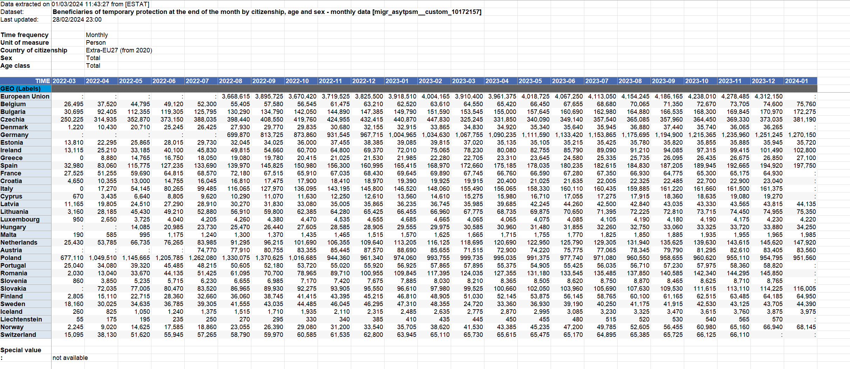

This dataset encompasses the statistics of non-EU citizens, who had fled Ukraine as a consequence of the Russian invasion in 2022, and were under temporary protection in the EU in the time period from 2022 to 2023. The provided table provides a peek into the table layout, yet it merely displays a segment of the entire dataset. Upon the acquisition of this data, a pivotal phase involves an exhaustive data cleaning process, designed to ensure the accuracy and reliability of the dataset. Rigorous measures are taken to address inconsistencies, rectify missing values, and eliminate redundant labels such as GEO (Labels), age class, sex, and so on. This meticulous cleaning process is vital in preparing the dataset for in-depth analysis, with particular attention given to handling ambiguous or missing entries. These efforts are undertaken with the overarching goal of preserving the integrity of the information and creating a solid foundation for subsequent visualisation.

## 2.2. Data Processing

To eliminate unnecessary data and align the details with the project's specifications, the tables must be properly cleaned. This guarantees that tables are optimized for optimal coding and data processing. According to Bhandari (2022), standardizing nation names across all tables is an important step in the cleaning process, as it allows for easier and more uniform coding. The records are simplified to retrieve the original values while ensuring data correctness. The appropriate time, country, and refugee numbers are kept to provide context and ease of analysis while maintaining the dataset's original structure.

Figure 2 depicts the necessary processes for cleaning up the initial table in order to assure data consistency and correctness. First, we needed to eliminate the GEO (Labels) and European Union rows, which included useless information and did not contribute to the total dataset. Furthermore, we noticed the significance of matching the nation names to the world_polygons JSON document that we were utilizing. Consistency in nation names allowed us to precisely match and integrate data from both files, making it easier to code. Not to mention, we also replaced the “:” which stands for not available value in the dataset to “0”, therefore making it easier to calculate the value to display on the webpage.

**Figure 2: Ukrainian Refugees to EU nations from 2022 to 2024**

# 3. Requirements

## 3.1. Must have features

### A choropleth map of the EU with selected countries

The site efficiently integrated a choropleth map of the European Union, that enabled smooth user interaction via nation selection. When users choose a country, they are effortlessly directed to a relevant line chart presenting relevant data. Additionally, when hovering over a specific nation, users can observe the number of Ukrainian emigrants to that country, represented by a corresponding color. This functionality was carried out precisely as envisioned.

### A line graph for Ukrainian refugees by nation

Moreover, the web page featured a separate line chart tracking the transit of Ukrainian migrants to the destination country. This graph provided valuable information on the flow of Ukrainian emigrants to various nations across different time periods. Users were able to communicate with the graph, thoroughly examine particular data points, and gain a thorough understanding of migration trends. The effective integration of these several visual representations enabled users to go into and thoroughly study migration data.

## 3.2 Optional features

### Line chart transition effect

The line chart now features an effortless transition effect. When users pick a value, a data point dot appears initially, followed by a connecting line that elegantly connects it to the other data points. This transition effect improves the graphical display of the data, providing viewers with a smooth and appealing experience.

### Choropleth map transition and animation effect

When filtering or updating the data, the choropleth map that depicts Ukrainian refugees in EU countries uses minimal animations and transitions. When viewers modify the time slider, the map's values and colors refresh seamlessly. These movements not merely bring about a visually beautiful impact, but also improve the user behavior during their visits to the visualisation.

# 4. Visualisation design

## 4.1 Design Ideas

In this final assignment, our team has chosen two separate visualisation methods: a choropleth map to illustrate the distribution of Ukrainian refugees throughout European states, and a line chart to demonstrate how the total number of Ukrainian migrants in each European nation has changed over time from Quarter 2, 2022 to Quarter 4, 2023.

### Choropleth map

Creating a choropleth map to reveal Ukrainian migrants' migratory patterns across European nations requires a comprehensive methodology. Initially, data gathering would be critical, with information sourced from reputable international organizations, and governmental agencies to get accurate and comprehensive statistics on refugee intake.

Delineating geographical borders, such as administrative areas or nations, would thus make it easier to describe refugee movements spatially. To ensure that the map successfully communicates relevant information without overwhelming the viewer, acceptable variables to display on the map, such as the number of refugees, their destinations, and demographic features, must be carefully selected.

Our preference is to create animations in which, when hovered over, a certain nation is emphasized with pronounced geographical demarcations and textual information indicating the number of Ukrainian refugees residing within that nation.

Furthermore, our team created a slider bar function to help display the number of Ukrainian refugees that have changed in each quarter from 2022 to 2023 and also the average amount of migrants in a specific period of time, improving the accessibility and navigability of the information displayed.

A sketch design:

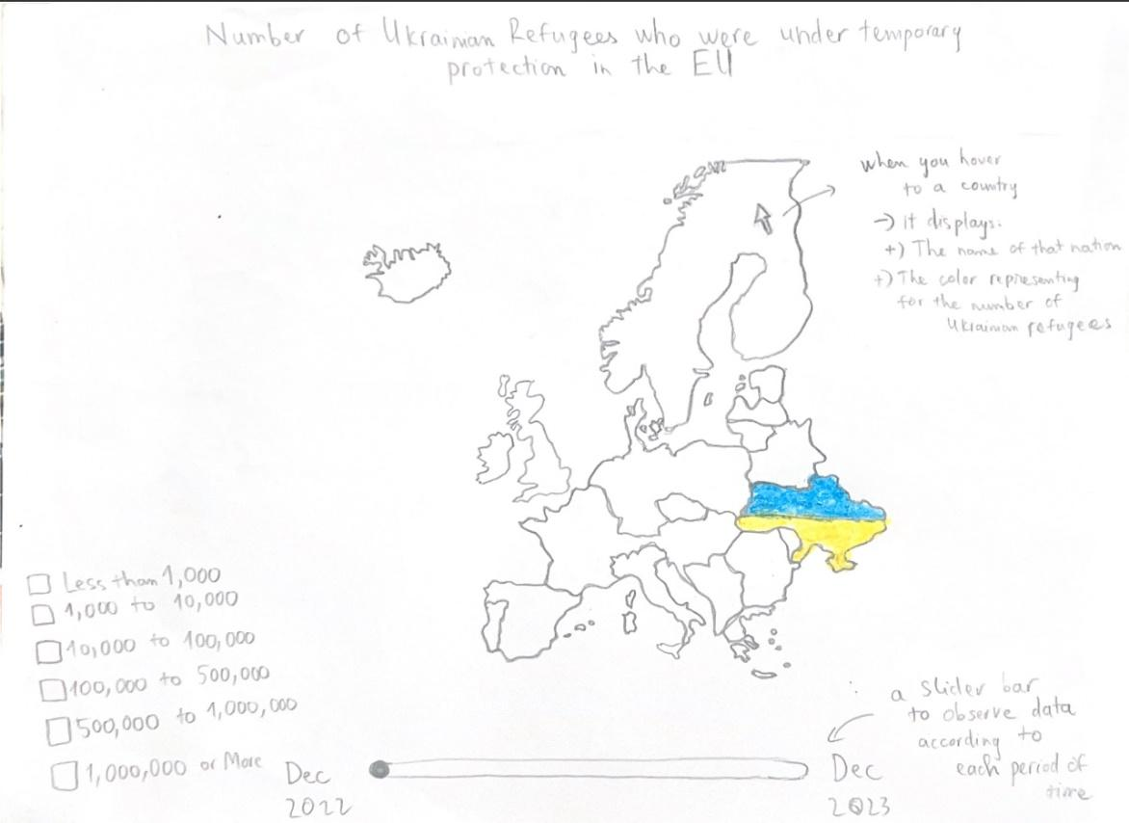

**Figure 3: Sketch design of choropleth map**

### Line chart

Several factors must be considered while developing the idea of using a line chart to show the chronological history of the overall number of Ukrainian migrants in all European countries.

Initially, a complete dataset covering various time periods would be required, obtained from credible international organizations, governmental bodies, or humanitarian groups. Subsequently, dividing the temporal axis into meaningful periods, such as months or years, would make it easier to display trends and variations throughout time. Choosing relevant variables, such as the overall number of refugees or the rate of movement, is critical for successfully communicating the A graph with lines and arrows
dynamics of the refugee crisis.

A sketch design:

**Figure 4: Sketch design of line chart**

## 4.2 Initial progress

During the iterative rounds of the design process, our team focused on refining different features and enhancing functions in both representations. While great progress has been achieved in increasing overall efficacy and user experience, several aspects of the visualisations remain work in progress, requiring more development and fine-tuning to attain maximum performance and clarity in delivering the desired information.

### Choropleth map

Within our visualisation framework, we successfully added tooltips to represent the names of nations as well as the relative numbers of Ukrainian refugees.

Furthermore, a draggable bar feature has been smoothly integrated to allow for the depiction of migrant numbers over many time periods. Moreover, the drag bar functionality not only enhances user control and interactivity but also serves as a conduit for analytical insights. By utilizing the drag bar, users can effectively discern the average number of refugees within a specific period, thereby fostering a more nuanced understanding of migration patterns and temporal fluctuations.

This multifaceted capability not only enriches the user experience but also elevates the utility of our visualisation as a tool for in-depth analysis and informed decision-making regarding refugee dynamics in Europe.

In addition, a distinct color pattern has been devised to properly reflect the varied magnitudes of refugee numbers, improving the visual clarity and interpretability of the displayed data.

Final design:

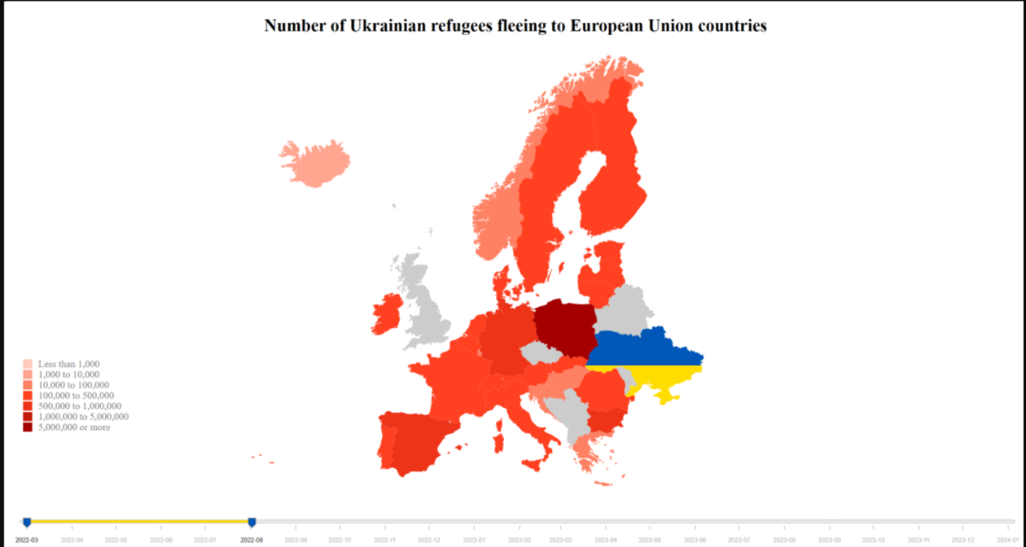

**Figure 5: Complete design of choropleth map**

### Line chart

Early in the study project, our group made great progress in creating a line graph that would show the variations in the number of Ukrainian refugees in different European countries.

We have made some progress in the design phase, sketching the basic framework of the chart. Furthermore, we have completely included dynamic elements, such as interactive animations along the line route to improve user engagement and comprehension. These animations use discrete data points represented by dots, each of which represents the number of refugees in a certain nation over a specified time.

In addition, we have included a tooltip capability to give consumers full information. When a user hovers over a data point, a tooltip emerges, providing extensive information on the matching refugee count, month, and year. Our visualisation modifications seek to provide an intuitive and informative user experience, allowing for a better comprehension of the growing migration dynamics in Europe.

Final design:

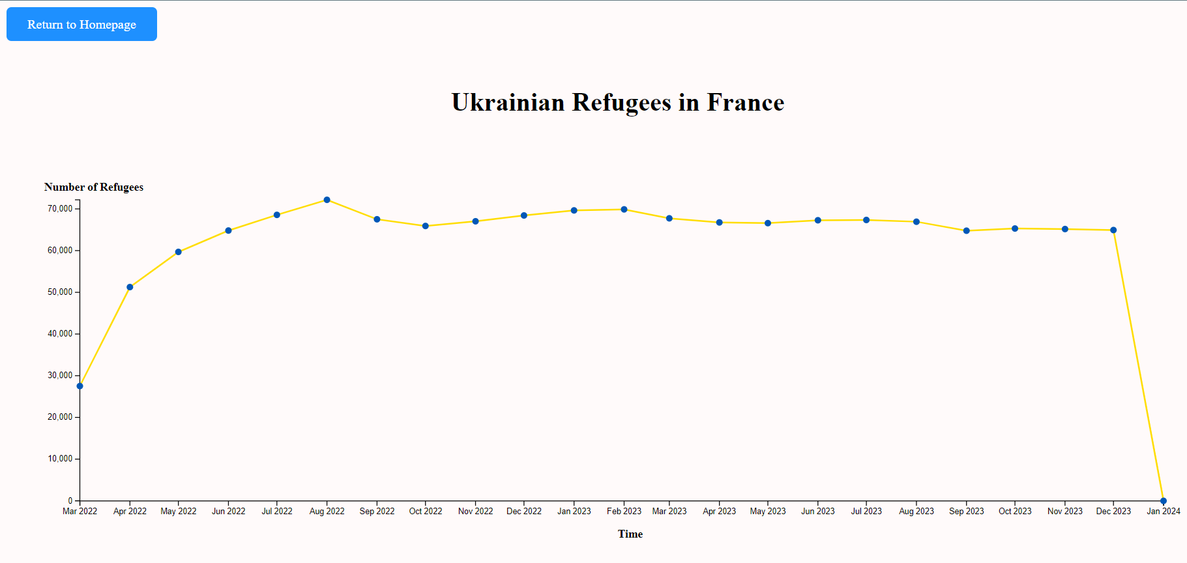

**Figure 6: Complete design of line chart**

## 4.3 Intention of Choosing Visualisation Types

### Choropleth map

According to a blog by Laura Short published on September 22, 2021, it was demonstrated that choropleth maps utilize color to depict how data varies from one location to another. These maps enable us to display geographic information while also comparing and analyzing data from several areas. Choropleths let readers perceive tales in statistics, such as using data to tell a story about a student competition or analyzing voting trends to gain insights into the political environment.

* Geographical context: Choropleth maps give geographic context, helping users to rapidly grasp the spatial distribution of Ukrainian migrants across Europe. This spatial viewpoint is critical for understanding migration patterns and trends within and between nations.
* Data aggregation: Choropleth maps allow users to aggregate data at the regional or country level, making it easier to view enormous datasets and discover broad movement trends. Choropleth maps, which use color gradients or shades to display data, may efficiently show changes in migrant populations across areas.
* Comparative analysis: Choropleth maps provide a comparative study by graphically contrasting the intensity of migration between European nations. The map's different hues or colors can emphasize locations with high or low numbers of Ukrainian migrants, allowing users to see trends and inequalities across regions.
* Decision-making assistance: Choropleth maps may help policymakers and stakeholders make decisions by offering useful insights about the spatial distribution of Ukrainian migrants throughout Europe, as well as the total number of refugees in some countries using the tooltip function. This data can help influence policy creation, resource allocation, and intervention initiatives focused on meeting the needs of migratory populations in various locations.

### Line chart

As mentioned in a blog from Tableau which instructs how to use line charts effectively, it depicts that line charts may be quite useful for tracking the behavior of data over a specific length of time. The audience will observe changes in the data, which are shown with a line linking each data point as it changes over time. Besides, the line chart makes it easier to track behavior in a group of data. These charts are valuable for more than just monitoring changes over time. They can also assist users in identifying discrepancies and connections between data points in the dataset.

* Time-series data: Using a line chart is appropriate for displaying time-series data, with the x-axis typically representing time (e.g., months, years) and the y-axis representing the number of Ukrainian refugees.
* Identifying patterns: One of our team’s objectives is to create a line chart to observe how the number of Ukrainian refugees in European countries has changed over time. Thus, this type of visualisation provides a clear and concise visualisation of data, making it easy for audiences to understand and interpret trends in Ukrainian refugee numbers over time.
* Highlighting outliers: The usage of drawing line charts can showcase outliers or extraordinary occurrences, such as abrupt surges or drops in refugee numbers, which may reflect crises or policy changes influencing migration patterns.

# 5. Conclusion

In summary, the process of creating our website to showcase the movement of Ukrainian refugees during the Russian invasion was a remarkable experience. Our objective was to establish an interactive platform that effectively presents the trends and patterns of Ukrainian emigration, with a specific focus on EU nations.

One of the pivotal features we implemented was a map of European Union nations. Users have the ability to explore the preferred locations of the refugees and select different time periods to observe the migratory movement. By hovering over each nation, users can access information about the number of refugees, providing them with a deeper understanding of the devastating impact of the war on local communities.

In addition, we incorporated a line graph to illustrate the influx of Ukrainian emigration to European Union nations, categorized by country. This graph enabled users to identify trends and changes over time, facilitating the analysis and comparison of migration patterns across different regions. Our aim was to present the data in a straightforward and comprehensible manner, offering valuable insights into the migration trends of the country.

Throughout the project, we encountered problems and made innovative choices to enhance user engagement and effectively convey the information. To foster engagement, we integrated features such as animations, dynamic elements, and tooltips. Furthermore, the implementation of various visual approaches, such as connecting lines and color gradient, effectively conveyed details and aided in data comprehension.

In conclusion, this project provided us with practical experience in designing and implementing data visualisation. We gained a deeper understanding of data preparation, design processes, visual techniques, user interaction, and the importance of striking a balance between elegance and utility. These lessons will prove invaluable for future endeavors that involve data visualisation, enabling us to effectively present our findings and create engaging data-driven narratives.

# 6. References

Bhandari, P. (2022). *Data Cleaning | A Guide with Examples & Steps*. [online] Scribbr. Available at: https://www.scribbr.co.uk/research-methods/data-cleaning/.

Short, L. (2021). What Is a Choropleth Map and Why Are They Useful? [online] Population Education. Available at: https://populationeducation.org/what-is-a-choropleth-map-and-why-are-they-useful/.

Tableau. (n.d.). Understanding and using Line Charts. [online] Available at: https://www.tableau.com/data-insights/reference-library/visual-analytics/charts/line-charts#:~:text=A%20line%20chart%2C%20also%20referred.